Appendix 7 - DRESS CODE

Our policy is to promote a professional image internally and externally. Each of us has as a primary responsibility to represent Rape Crisis North East in line with our professional image. To this end, all employees must present themselves in all aspects including attire in a business-like manner appropriate to this policy.

The primary factor for determining appropriate attire is the likelihood of contact with customers and other parties. Our dress policy for contact with customers and other parties is standard business attire. The overriding policy is for everyone to use good judgement in selecting their attire based on the situation at hand. The attached is a guideline for appropriate standard business and business casual attire.

Guidelines

To clarify our definition of appropriate and inappropriate clothing items for business use, we listed some guidelines below. Please use the list as a guide for determining your own attire. If you have questions about particular clothing items, please clarify with your manager.

Any employee whose appearance is not in keeping with the spirit of Rape Crisis North East’s dress code policy standard will be required to correct the problem immediately.

Standard Business Attire
Appropriate Inappropriate

Suits Leisure or sports wear
Ties Undersized/revealing clothes
Dress shirts Leather of any description
Trousers Hiking, casual or sports shoes
Blazers or sport coats Midriff or tank tops
Blouses String tops or dresses
Skirts or work dresses Ripped jeans
Skirt and trouser suits Flip flops

Business Casual Attire

"Business Casual" means casual clothing that is appropriate for a professional, office environment. Business casual comprises clothing that always looks neat and presentable.

Appropriate Inappropriate

Collared polo shirts T-shirts of any variety
Button down shirts Oversized/super baggy clothing
Smart shirts/blouses Undersized or revealing clothes
Sweaters or cardigans Midriff or tank tops
Polo or Turtleneck shirts Leggings or shorts
Sports jackets or blazers Walking or beach sandals
Casual or chino trousers (or unripped jeans) Leisure or sports-wear including hats
Business or "smart casual" footwear Hiking or sports footwear
Skirts or smart dresses Ripped jeans

Signed:
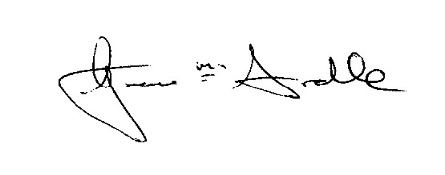
Position: RCNE Manager Agreed by the Board: 15th September 2020

Review Date: YEAR 2023

