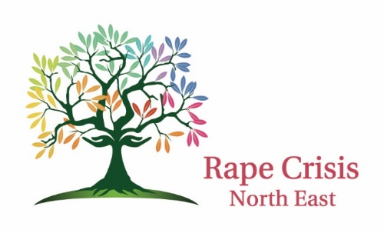

Social Media Policy

Updated May 2021

Rape Crisis North East (RCNE) Social Media Channels
Rape Crisis North East (RCNE) uses the following social media channels:
- Facebook @
- Twitter @
- Instagram
- Linked In

All channels are managed and monitored by the RCNE Social Media / Administrator Officer who is answerable to the Manager. This policy details the type of content we publish as well as how we interact with others on our platforms.
Our social media channels allow us to communicate RCNE news and updates in a timely manner and disseminate information of interest to the RCNE mission. They are not intended as a means for booking or requesting counselling services, reporting an assault or submitting press queries.

- For counselling services please contact info@rcne.ie or 1800 21 21 22
- For a Sexual Assault Trauma Unit, click here
- For information on reporting an assault, click here
- Queries from the press should be directed to manager@rcne.ie

Content
If you follow us on social media, you can expect posts covering some or all of the following:
- Press releases on RCNE activities
- Statements on RCNE policy
- Updates on RCNE research
- Announcements regarding RCNE staff activity
- RCNE event information
- Content relevant to RCNE mission, ethos and policy
- Alerts about the new content on our website.

Who we follow
If you follow us, we will not automatically follow you back.
A follow is not an endorsement.
RCNE social media accounts follow policy, legislative and cultural influencers such as Governmental Department accounts, other NGOs, Houses of the Oireachtas, TDs, Senators, public figures, journalists, members of the public and institutions and accounts of particular relevance to issues around domestic, sexual and gender-based violence in Ireland and internationally. RCNE retains the right to follow other social media accounts at our discretion and will not engage in dialogue regarding the advisability, propriety or suitability of such from other platform users.

Replies and Direct Messages
We welcome feedback and engagement from our followers and will try to join the conversation where possible and relevant. However, we do not ordinarily reply individually to all the messages we receive via social media.
Please do not include private or personal information when contacting us via social media. The best means of communicating a query is by contacting us via the details on our website.
While we try only to like and retweet material that we endorse, we are not responsible for the content of third parties’ posts, or their previous public engagements or policy positions.
Abusive, discriminatory, harassing, derogatory, defamatory or inappropriate content, posts or messages will be deleted and result in followers being blocked and reported directly through the dedicated channels of the social media platform where the abuse took place.

Availability
Our social media accounts may occasionally be unavailable and we accept no responsibility for lack of service due to platform downtime. Typically, we update and monitor our accounts during normal office hours – 9.00am – 5:00 pm Monday to Friday. We may also update and monitor the accounts outside of these hours at our own discretion.

Signed:
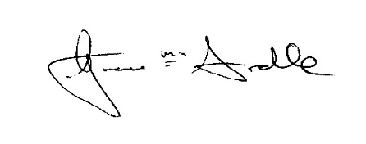
Position: RCNE Manager Date: 25th May 2021

Review Date: YEAR 2024

