Safety Policy & Objectives

The Management recognise that the greatest assets of Rape Crisis North East CLG are its employees and, to this end we endeavour to promote a spirit of cooperation, participation and partnership within all aspects of our business. In this spirit, we must continue to develop our own ethos on Health & Safety and implement suitable policies for securing the Safety and Health at work of all our employees, so far as is reasonably practicable.

It is the expressed wish of the Management that the activities of Rape Crisis North East CLG through its employees, will become synonymous throughout all our activities with Best Practices in Health & Safety as well as inherent to our practices over coming months and years. We would ask everyone to work towards this aim by taking care of themselves at all times, by being aware of any potential hazards and by implementing and adhering to the policies and procedures detailed in this Safety Statement fully on a day-to-day basis.

Rape Crisis North East CLG has an existing and active policy of regular and ongoing consultation with employees. This will obviously continue and has a particular relevance in Health & Safety issues and the various policies and procedures in this regard are detailed herein. All employees are encouraged to put forward suggestions and ideas for consideration and for improving standards of Health & Safety about the premises.

It is the intention of the Manager to review this Safety Statement to a regular schedule and in the light of developments in our premises and in industry generally. We are also committed to providing sufficient resources in time, personnel and finance to ensuring, so far as is reasonably practicable, the safety of all employees and persons who are on our premises at any time.

The Manager is committed to the continuing development and implementation of policies for securing the health and safety of our employees, so far as is reasonably practicable. This is actively supported by means of the on-going training and awareness programmes, which help to reinforce the company's safety strategy, as detailed in this Safety Statement.

Rape Crisis North East CLG shall ensure that all works that their employees are carrying out during the Coronavirus (COVID-19) pandemic are protecting their workforce and minimising the risk of spread of infection which we are committed to in full and shall prioritise everything to achieve same.

We also encourage the participation of the Safety Representative and recognise that safety issues raised by him/her through consultation with Management must be assessed and resolved in a satisfactory way.

We look forward to working with you all towards achieving this policy in the coming months and years.

Signed:
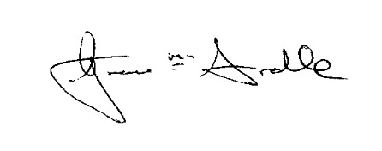
Position: RCNE Manager Date: 25th May 2021

Review Date: YEAR 2024

