

FRAUD POLICY

Policy and procedures for the prevention and detection of fraud, corruption and other irregularities affecting Rape Crisis North East.

Introduction

The purpose of this policy is to set out how the Company protects itself from losses from fraud, corruption and other irregularities.

Fraud is defined as dishonest, irregular or illegal acts, characterised by a deliberate intent at concealment or false representation, resulting in the diversion of resources, whether or not for personal gain, for the benefit of an individual or group of individuals and resulting in a loss or the potential loss of resources to the Company.

Corruption is the action of a member of staff or office holder who allow themselves to be influenced by a third party, usually by the receipt of some benefit, to act or appear to act in a way that is detrimental to the best interest of the Company in order to benefit the third party or some other group or individual.

For the purpose of the remainder of this policy fraud is used to describe all forms of fraud, corruption or other irregularity.

Prevention and Detection

The Company's Senior Managers and Directors are committed to the highest standards of behaviour and a strict policy on conflict of interest, including the registration of interests, is maintained.

The aftermath of fraud is costly, time-consuming, disruptive and unpleasant. The Company's approach is therefore to place emphasis on the prevention of fraud, though all of these systems also play a significant role in the detection of fraud, through the implementation of its financial regulations and procedures and other policies as they impact on staff's conduct, including:

- The design and operation of systems so as to minimise the opportunity of fraud including the segregation of duties, authorisation requirements etc.
- Control of access to IT systems
- Application of formal tendering requirements and process for approving suppliers and for monitoring the use of non-approved suppliers
- Informing all staff of their obligations to secure the financial resources of the Company from loss
- Staff adherence to the Company's policy on Acceptance of Gifts
- Staff adherence to the Company's policy on Conflicts of Interest

Prosecution

The Company's policy is that it will report to the authorities any cases of suspected fraud and irregularity. Any exceptions to this policy must be agreed by the Managing Director.

Signed:
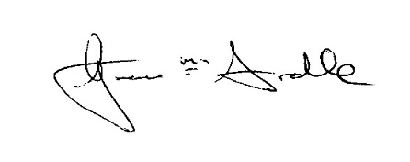
Position: RCNE Manager Date: 28th May 2019

Review Date: YEAR 2022

