

COMPANIES ACT 2014

CONSTITUTION OF RAPE CRISIS NORTH EAST CENTRE A COMPANY LIMITED BY GUARANTEE AND
NOT HAVING A SHARE CAPITAL

AS ADOPTED BY SPECIAL RESOLUTION ON: 15th November 2016  TABLE OF CONTENTS

Page
Memorandum of Association ..................................................................................................................2
Articles of Association to Accompany Preceding Memorandum of Association.................................... 8
Interpretation.........:..................................................................................................................................8
The Act.................................................................................................................................................... 9

Members..................................................................................................................................................9
General Meetings................................................................................................................................. 10
Votes of Members............................................................................................................................ … 10
Directors................................................................................................................................................10
Powers and Duties of Directors.............................................................................................................10
Voting on Contracts...........................................................................................................................….11
Rotation of Directors..............................................................................................................................11
Secretary...............................................................................................................................................11
The Seal.................................................................................................................................................11

Audit...................................................................................................................................................... 11

1

MEMORANDUM OF ASSOCIATION OF RAPE CRISIS NORTH EAST COMPANY LIMITED BY GUARANTEE

- The name of the Company is Rape Crisis North East Company Limited by Guarantee (the "Company").¹

- The Company is a company limited by guarantee, registered under Part 18 of the Companies Act 2014.

- (a) The main object for which the Company is established is to provide a total support service to survivors of sexual violence. These services include counselling, Information, training, education and support for survivors of sexual violence and their families.
- In furtherance exclusively of the main object, the Company will have the following subsidiary objects and any income generated from the subsidiary objects is to be applied to the. main object only:

  - To provide free and confidential unlimited counselling services to the survivors of sexual violence and crimes.
  - To provide a programme of supports to survivors of sexual violence and crimes, their families and friends.
  - To educate and inform the communities in which the company operates and to create awareness and understanding of the effects of sexual crimes.
  - To continue to actively participate in local and national level networks and fora that will have a direct impact on our work, will raise our profile and-enhance information sharing.
  - To provide for the continued professional development of our staff and volunteers.
  - To foster a greater awareness in society of the dynamics and impact of sexual violence and crime.

2

- To the extent that the same are essential or ancillary to the promotion of the main object of the Company, the Company may exercise all such powers and do all other such things as are incidental to the attainment of the main object of the Company which includes the following powers which are not exhaustive and shall not be taken as limiting the company to these powers.

  - To employ stewards, caretakers, porters, counsellors, secretaries, administrators, managers and other personnel deemed necessary or useful to the company

  - To repair, maintain, decorate, preserve, improve, cultivate and insure the companies property and to make arrangements for the collection of refuse and other services and amenities;

  - to purchase, acquire, hold, sell, exchange, partition, mortgage, charge, lease, dispose of, hire and rent property whether real or personal.

  - To furnish and provide the company's property with such furniture, implements, machinery and conveniences as the company may think desirable.

  - to provide gardens, greenhouses and grounds for recreation and amenities.

  - To levy and collect service charges as the company may from time to time determine

  - To raise funds and to help raise funds for any charitable purpose

  - To acquire and or carry on any other business which may seem to the Company capable of being conveniently carried on in connection with the above or which may seem calculated directly or indirectly to enhance the value or render more profitable any o the company's property or rights.

  - To purchase, take on lease or in exchange hire or by any other means acquire and protect any freehold, leasehold or any other property or any estate or
interest any lands, buildings, stock in trade and any real or personal property or rights whatsoever which may be considered necessary, advantageous or useful to the company

0) To borrow raise or secure the payment of money in such manner as the company shall think fit and in particular to issue debentures of all kinds and to charge and secure the same by Trust Deed or otherwise on the undertaking of the Company or upon any specific property and rights, present and future of the company.

(k) To guarantee, support or secure whether by mortgaging or charging all or any part of the undertaking, property and assets both present and future of the Company or both the performance and discharge of any contract obligation or liability of a company or of any person or corporation with whom or which the company has dealings or having a business or undertaking in which the company is concerned or interested whether directly or indirectly and in particular to give security for any debts, obligation or liabilities of any company.

(I) To pay or remunerate any person, firm or company for rendering services on or on behalf of this company and to pay any costs, charges or expenses incurred or sustained by or in connection with the formation and incorporation of this company.

  - To invest and deal with the monies of the company not immediately required for the purpose of its business or upon such investments or securities and in such manner as may from time to time be determined, provided however that prior notification will always be given to the revenue Commissioners where it is intended to accumulate funds over a period in excess of two years for any specific purpose.

  - To develop, improve, manage, cultivate, exchange let on lease or otherwise mortgage, charge, sell, dispose of, turn to account, grant rights and privileges in respect of or otherwise deal with all or any part of the property or rights of the company.

  - To effect insurances and to take such other measures as may be considered necessary or expedient for the purposes of safeguarding and securing the Company and its Directors, Members, Employees and people using its premises and any property of which the Company may be a Trustee, Manager, Agent or Custodian against liability loss and damage of every description.

  - To enter into and carry into effect any arrangement with any person, firm, company or Government or Government Body or Authority that may seem conducive to the Company's main objects and to apply for, promote and obtain from any person, firm, Government or Government Body or authority any contracts, concession, privileges, charters, decrees and rights which the company may think is desirable and to carry out, exercise and comply with same.

  - To purchase or otherwise acquire and undertake all or any part of the business, property, goodwill, assets, liabilities and transaction of any person, firm or company carrying on any business which this company is authorized to carry on.

  - To undertake and execute the office of nominee, trustee, executor, administrator, registrar, secretary committee or attorney for any purpose

and either solely or jointly with others and generally to undertake, perform and fulfil any office of trust or confidence.

  - To accept payment for any property or rights sold or otherwise disposed or dealt with by the company in whatever form and on such terms as the Company may determine.

  - To establish, promote or otherwise assist any company and to promote or otherwise assist any person or firm for the purpose of acquiring all or any of the properties and/or liabilities or for furthering the main objects of this company or for the purpose of instigating or opposing any proceedings or applications which may be considered necessary, advantageous or useful to the company.

  - To procure the company to be registered or recognized in any place outside of Ireland.

  - To do all such things as are incidental or conducive to the attainment of the above main objects.

  - To take over from existing trustees and hold either alone or jointly all or any existing charitable or benevolent funds, investment and burses established for or used in connection with these main objects or objectives for the community or social services or allied undertakings.

- To grant pensions, gratuities, allowances or charitable aid to any person who may have served the company as an employee or to the wives, husbands, children or other dependants of such person provided that such pensions, gratuities, allowances or charitable aid shall be no more than provided by an occupational pension scheme and provided that such occupational pension scheme has been operated by the company and the beneficiary of the pensions gratuities, allowances or charitable aid or occupational pension scheme while employed by the company and to make payments towards insurance and to form and contribute to provident and benefit funds for the benefit of any persons employment by the company and to subscribe or guarantee money for charitable objects.

- The Company shall not support with its funds any objects or endeavour to impose or procure to be observed by its members or others any regulations, restriction or condition which, if an object of the Company would make it a trade union.
- The income and property of the Company shall be applied solely towards the promotion of the main object(s) as set forth in this Constitution. No portion of the Company's Income and property shall be paid or transferred directly or indirectly by way of dividend, bonus or otherwise howsoever by way of profit to members of the Company. No Director shall be appointed to any office of the Company paid by salary or fees, or receive any remuneration or other benefit in money or money's

worth from the Company. However, nothing shall prevent any payment in good faith by the Company of:

- Reasonable and proper remuneration to any member or servant of the Company (not being a Director) for any services rendered to the Company;

- interest at a rate not exceeding 1% above the Euro Interbank Offered Rate (Euribor) per annum on money lent by Directors or other members of the company to the
Company;
- reasonable and proper rent for premises demised and let by any member of the Company (including any Director) to the Company;

- reasonable and proper out-of-pocket expenses incurred by any Director in connection-with their attendance to any matter affecting the Company;
- fees, remuneration or other benefit in money or money's worth to any Company of which a Director may be a member holding not more than one hundredth part of the issued capital of such Company;
- nothing shall prevent any payment by the Company to a person pursuant to an agreement entered into in compliance with section 89 of the Charities Act, 2009 (as for the time being amended, extended or replaced).
- The Company must ensure that the Charities Regulatory Authority has a copy of its most recent Constitution. If it is proposed to make an amendment to this
Constitution, which requires the prior approval of the Charities Regulatory Authority, advance notice in writing of the proposed changes must be given to the . Charities Regulatory Authority for approval, and the amendment shall not take effect until such approval is received.
- No amendment of any kind shall be made to the provisions of clauses [8] and [12]² of the memorandum of association and no amendments shall be made to the memorandum and articles of association to such extent that they would alter the effect of Clauses [8] and [12] of the memorandum of association, such that there would be non-compliance with the requirements of section 971/1180 of the Companies Act 2014.

- The liability of the members of the Company (the "Members") is limited.

- Annual audited accounts shall be kept and made available to the Revenue Commissioners on request.

- If upon the winding up or dissolution of the Company there remains after the satisfaction of all its debts and liabilities any property whatsoever, the same shall not
be paid to or distributed among the members of the Company. The company or companies to which the property is to be given or transferred shall prohibit the distribution of their income and property among their members to an extent at least as great as is imposed on the Company under or by virtue of Clause [8] hereof. Members of the Company shall select the relevant company or· companies at or before the time of dissolution, and if and so far as effect cannot be given to such provisions, then the property shall be given or transferred to some charitable object with the agreement of the Charities Regulatory Authority. Final accounts will be prepared and submitted that will include a section that identifies and values any assets transferred along with the details of the recipients and the terms of the transfer.

- Every member of the Company undertakes to contribute to the assets of the Company in the event of its being wound up while he is a member or within one year afterwards, for payment of debts and liabilities of the Company contracted before he ceases to be a member and the costs, charges and expenses of winding up and for the adjustment of the rights of the contributories among themselves, such amount as may be required not exceeding One Euro.

- Prior permission of the Revenue Commissioners shall be obtained where it is
intended to accumulate funds for a period in excess of two (2) years.

ARTICLES OF ASSOCIATION³⁴ TO ACCOMPANY PRECEDING MEMORANDUM OF
ASSOCIATION OF RAPE CRISIS NORTH EAST CENTRE COMPANY LIMITED BY GUARANTEE

The following regulations shall apply to the Company:

Interpretation

1. In these Articles: -

"Act" means the Companies Act, 2014;
"Board" means the board of the Company;
"Company" means [Name of the Company];
"Directors" means the Directors for the time being of the Company or the Directors present at a meeting of the board of Directors and includes any person occupying the position of director by whatever name called;

"in writing" means written or produced by any substitute for writing, or partly one and partly another;

"Ireland" means the territory of the Republic of Ireland;
"Member" means a member ofthe Company;
"Month" means calendar month;

"the Office" means the registered Office for the time being of the Company;
"the Seal" means the common Seal of the Company;
"Secretary" means any person appointed to perform the duties of the Secretary of the Company; and

"Year'' means calendar year.

Expressions referring to writing shall be construed, unless the contrary intention appears, be construed as including references to email, facsimile, printing, lithography; photography and any other modes of representing or reproducing words in a visible form, provided, however, that it shall not include writing in any other electric form except as provided in these Articles and/or where it constituted writing in electric form sent to the Company, the Directors have approved its receipt in such Form. Expressions in these Articles referring to execution of any document shall include any mode of execution under Seal or under hand or any mode of electronic signature as shall be approved by the Directors.

Unless the contrary intention appears, words or expressions contained in these Articles shall bear the same meaning as in the Act or any statutory modification thereof in force at the date at which these Articles become binding on the Company.

The Act

- The provisions of the Act are adopted subject to Article 3 and the modifications contained herein.

- The Company notes the sections of the Act specifically disapplied in respect of companies limited by guarantee under Part 18 of the Act and further disapplies the following Sections of the Act: 188 (2)(b), 618{1)(b), 1196, and 1198.

Members⁵

- The number of Members the Company proposes to be registered with is 8 however, the Directors may increase this number and, where an increase is made, it shall notify the Companies Registration Office of the details of the increase within 15 days of the date on which the increase was resolved or took place.

- The subscribers to this Constitution and such other persons and categories of eligible entities as determined by the Directors who meet the membership terms as set down in the document entitled the [Company Governance Handbook/Terms of Membership of COMPANY as may be amended by the Directors from time to time {the "Company Governance Handbook/Terms of Membership of COMPANY" shall be the members of the Company and shall be entered in the register of members kept in accordance with the Act.

Obligations of Members

- Every member shall as a continuing condition of membership be bound by the provisions of the Constitution of the Company and any amendment thereof, and shall observe all (if any) rules or regulations made from time to time by the Company in general meeting or by the Board.

- Membership of the Company shall cease:

  - on the Member's death or bankruptcy;

  - if the Member resigns by notice in writing, to the Secretary at the Company's Office; or

  - If the Directors determine that such member has failed to observe the membership terms as set down in the Company Governance Handbook/Terms of Membership of COMPANY.

  - If the directors determine that such a member has ceased to be a member and notice in writing of such decision is given to him or sent to his last known address.

General Meetings

- The quorum for a general meeting shall be 3 Members present in person or by proxy.

- An extraordinary general meeting may be called at any time by the Secretary on request from at least 2 of the Members entitled to vote at a general meeting.

Votes of Members

- Every Member shall have one vote.

Directors⁶

- The number of the Directors shall be 8 but shall never be less than 3.

- The requirements for directorship, election rules and provisions supplemental to the requirements of the Act in relation to removal and vacation of the office of Director are as set out in the "Company Governance Handbook/Terms of Elections of COMPANY".

- The quorum for a meeting of directors shall be 3 directors present in person or by suitable electronic means to allow them to actively participate in the board meeting.

- The Directors may be paid travelling, hotel and other expenses properly incurred by them in attending and returning from meetings of the Directors or any committee of the Directors or General Meetings of the Company or in connection with the business of the Company.

Powers and Duties of Directors

- The powers and duties of Directors are as set out in the Act.

- The Directors may delegate any of their powers to committees consisting of such Member or Members of the board as they think fit; any committee so formed shall, in the exercise of the powers so delegated, conform to any regulations that may be imposed on it by the Directors. The membership structure and terms of reference of any committee established by the Directors shall be as set out in the Company's Governance Handbook. Any such committees report to the Board of Directors.

10

Voting on Contracts

- A director may not vote in respect of any contract in which he is interested or any matter arising thereout.

Rotation of Directors

- The rotation of Directors shall be in accordance with the provisions of the "Company Governance Handbook/Terms of Elections of the COMPANY".

Secretary

- The Secretary shall be appointed by the Directors for such term and upon such conditions as they may think fit; and any Secretary so appointed may be removed by them.

- A provision of the Act or these Articles requiring or authorising a thing to be done by or to a director and the Secretary shall not be satisfied by its being done by or to the same person acting both as director and as, or in place of, the Secretary.

The Seal

- The Seal shall be used only by the authority of the Directors or of a committee of Directors authorised by the Directors in that behalf, and every instrument to which the
Seal shall be affixed shall be signed by a director and shall be countersigned by the Secretary or by a second director or by some other person appointed by the Directors for the purpose.

- Auditors shall be appointed, and their duties regulated in accordance with Sections 333 to 337 of the Act.
11

We the several persons, whose names and addresses are subscribed, wish to be formed into a company in pursuance of this constitution.

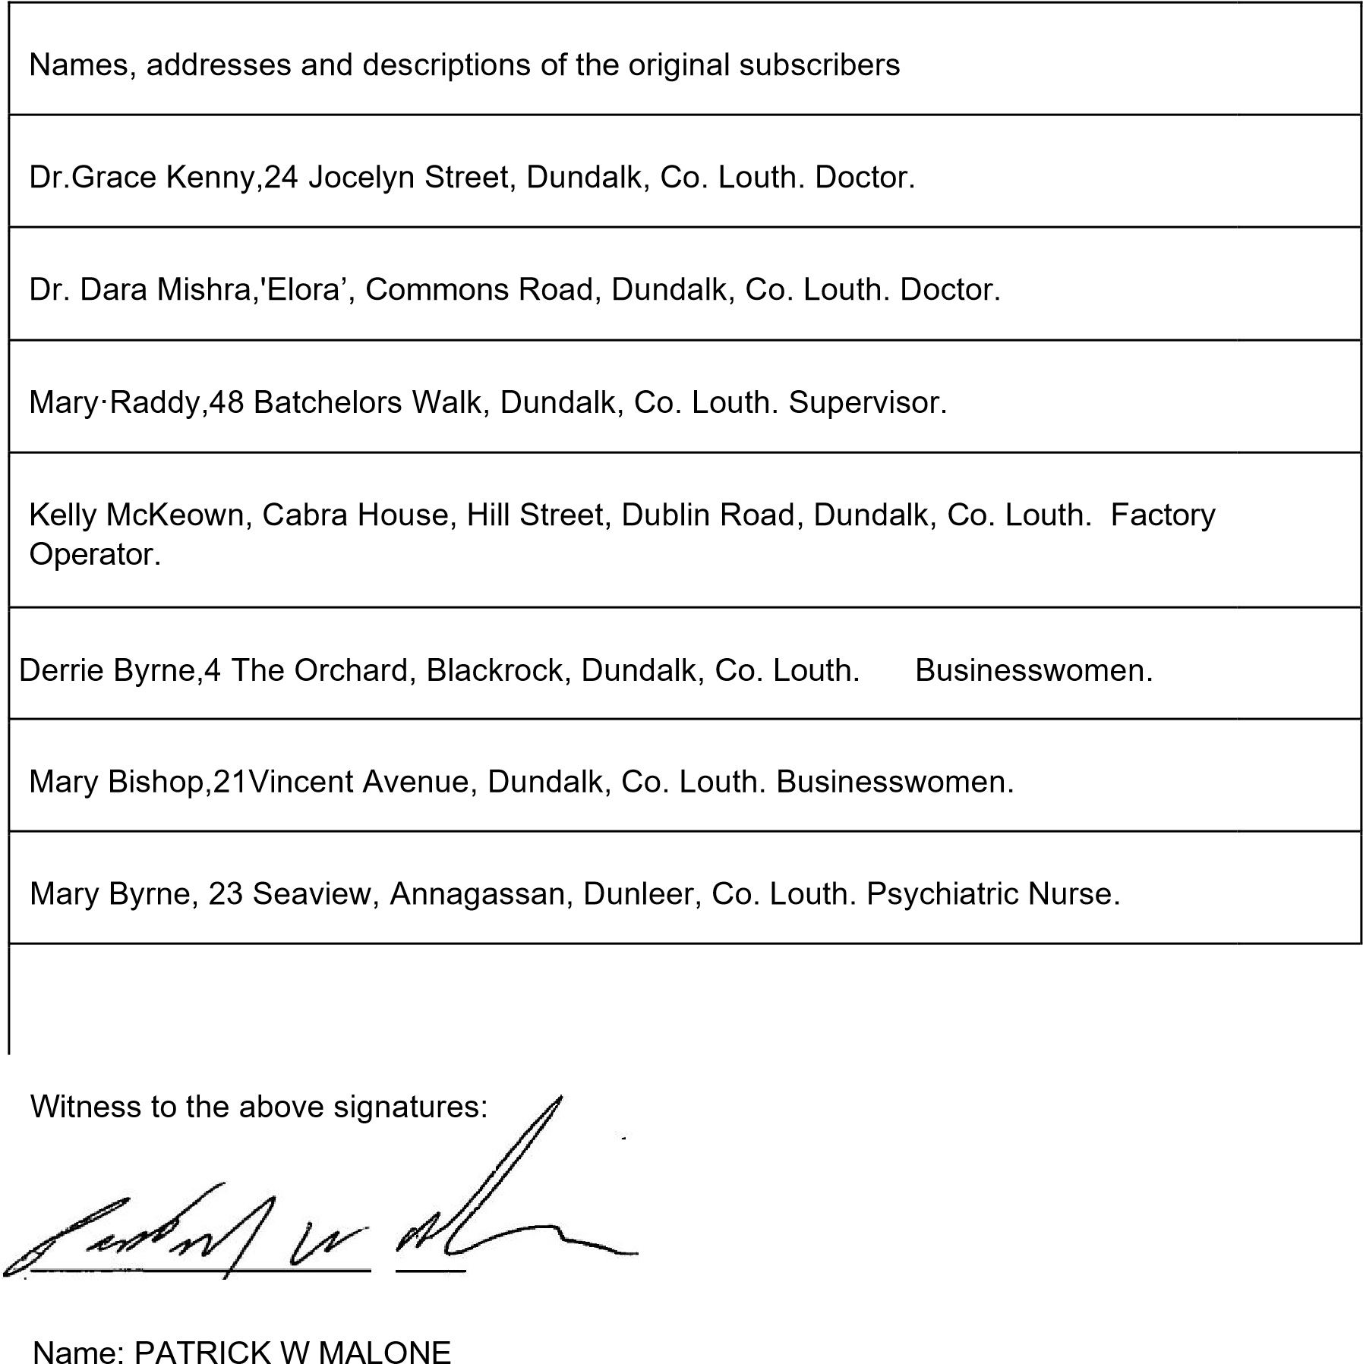
Occupation: CHARTERED ACCOUNTANT
Address: 6 Clanbrassil Street,
Dundalk,
Co. Louth

12

